7.1. Strategic Fit and Macro Business Opportunity

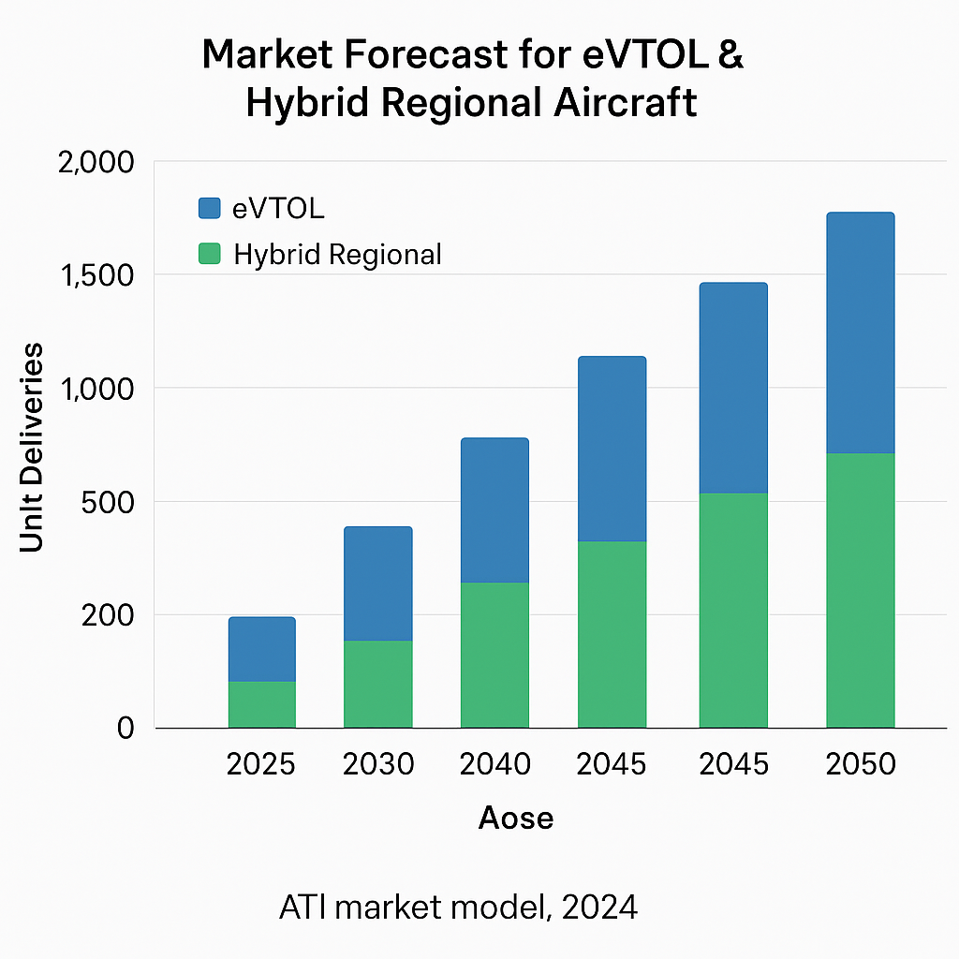
The global aerospace sector is undergoing a structural transition driven by decarbonisation imperatives, regulatory pressure, and rapid growth in advanced air mobility and regional aviation. UK passenger demand is forecast to reach 435 million by 2050, while global demand exceeds 38,000 new aircraft valued at approximately £4.65 trillion over the next two decades. At the same time, the UK aerospace sector contributes over £35 billion annually to the economy and sustains more than 120,000 high value jobs across nearly 3,000 supply chain companies.

SkyDrive directly aligns with the UK Aerospace Growth Partnership ambition for Net Zero Aviation by 2050 and supports the Jet Zero and Destination Net Zero strategies. These strategies prioritise electrification, hybridisation, and zero emission propulsion as enabling technologies for future aircraft. ATI and industry co investment of £1.37 billion between 2022 and 2025 is expected to unlock over £20 billion of private investment by 2040, creating a strong window for UK led propulsion platforms that are certifiable, scalable, and export ready.

SkyDrive addresses this strategic opportunity by developing an integrated, fault tolerant, high voltage electric propulsion system designed from first principles for aerospace certification and duty cycles. Unlike adapted automotive or industrial systems, SkyDrive
Figure 1:Illustrates the forecast growth of eVTOL and hybrid regional aircraft markets, demonstrating the scale of opportunity for certifiable electric propulsion systems such as SkyDrive.
is optimised for continuous high-power operation, redundancy,
thermal management, and regulatory compliance, enabling the UK to capture a meaningful share of the rapidly expanding eVTOL, hybrid regional aircraft, and future narrow body electrification markets.

7.1.1. Customer Led Deployment and Scaling Pathway

- Phase 1, non-primary propulsion deployment on Pegasus
- Phase 2, production ramp and data driven certification maturity
- Phase 3, primary propulsion integration on Linx P9
- Phase 4, replication across other OEM platforms

7.2. Market Opportunity and Customer Pull

OEMs and Tier1 suppliers are demanding propulsion systems that deliver higher power density, certification readiness, and operational reliability while reducing integration complexity and lifecycle cost. Industry targets indicate propulsion power density requirements of approximately 1.5 kW per kg by 2026, increasing toward 3.5 kW per kg by 2050, alongside fault tolerance and high voltage operation in the 1kV class.

SkyDrive responds directly to these market needs through a modular 100kW propulsion unit optimised for eVTOL platforms, commuter aircraft in the 6 to 19 seat class, and retrofit or demonstrator aircraft. The architecture supports scalability through distributed propulsion or stacking for larger regional and single aisle aircraft, while hybridisation with hydrogen fuel cells extends endurance beyond battery only solutions.

Customer engagement to date demonstrates clear market pull. ARC Aero Systems has committed to integrating SkyDrive within its Pegasus III hybrid gyrocopter and future Linx P9 platform. Eaton, as a Tier1 aerospace supplier, is actively supporting system architecture, certification strategy, and industrialisation planning. Wider engagement with Boeing, Rolls Royce Electrical, Ontic, Beyond Gravity, and Vertical Aerospace confirms demand for compact, certifiable electric propulsion systems that reduce programme risk and accelerate time to market. ARC Aero Systems has identified SkyDrive as a near term propulsion solution for its Pegasus programme, with a defined role as a jump take off propulsion module, and a long-term pathway toward primary propulsion integration within the Linx P9 nine-seater platform. This staged adoption reduces commercial and certification risk while enabling progressive scale up.

7.2.1. OEM and Tier1 Value Proposition

- Reduced integration effort
- Reduced certification burden
- Reduced programme risk
- Faster time to market
- Lower total cost of ownership

7.3. Technical Differentiation versus State of the Art

Current electric propulsion solutions are constrained by battery energy density, insulation degradation at high voltage, limited fault tolerance, and fragmented system architectures. Many existing solutions rely on single phase machines, heavy passive filtering, or low voltage operation, leading to excessive mass, thermal inefficiency, and certification complexity.

SkyDrive advances the state of the art through system level integration of multiple enabling technologies:

- A multi-phase high voltage electric motor operating at 1kV and 18,000 rpm, providing inherent redundancy and graceful degradation under fault conditions
- A modular multi-level inverter architecture that mitigates partial discharge, reduces electromagnetic interference, and enables fault reconfiguration
- An integrated battery and hydrogen fuel cell balancing converter enabling optimal utilisation of hybrid energy sources
- Advanced thermal management and cooling integration reducing passive component size and extending component lifetime
- A fully integrated motor, inverter, and energy management package designed for joint certification, reducing cabling, tuning effort, and system integration burden

This combination delivers a propulsion system that is unmatched in terms of power density, efficiency, fault tolerance, and certification readiness within its power class. Importantly, SkyDrive is not a single point solution but a scalable architecture that can be extended from 100kW modules toward megawatt class propulsion using common design rules, manufacturing processes, and certification artefacts.

7.3.1. Scalability Beyond Initial Launch Platforms

SkyDrive has been developed as a modular propulsion architecture rather than a platform specific solution, enabling deployment across multiple aircraft classes and commercial models. The SkyDrive IM integrated motor drive can be supplied either as a complete certifiable propulsion module or licensed at component level, allowing OEMs flexibility in integration strategy. This modular approach supports application across eVTOL platforms, hybrid regional aircraft, and unmanned aerial systems, all of which share common requirements for power density, fault tolerance, and certification readiness. ARC Aero Systems acts as the launch customer, validating SkyDrive through early deployment on the Pegasus programme and progression toward the Linx P9 platform, but the architecture is not dependent on a single airframe or customer. Certification artefacts generated through this programme are structured for reuse across derivative products and future customer integrations, reducing time to market and cost for subsequent adopters and enabling rapid scaling into international markets, supporting export led growth of UK designed and manufactured propulsion systems.

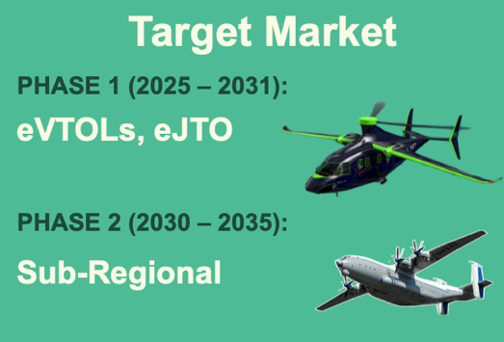
7.4. Business Model, Revenue Streams, and UK Value Creation
Figure 2: Target Market Phasing Diagram

SkyDrive targets three complementary revenue streams that together support a sustainable and scalable UK business model.

SkyDrive IM is the integrated motor drive product targeting eVTOLs, hybrid general aviation aircraft, and UAV platforms. Unit pricing is forecast at approximately £35k, with demand projected at 200 units by 2031 and over 1,000 units by 2035.

SkyDrive HPro is the hybrid propulsion configuration incorporating battery and fuel cell balancing for extended range applications, including regional aircraft and long endurance UAVs. Unit pricing is forecast at approximately £80k, reflecting higher system complexity and certification value.

SkyDrive Services provides recurring revenue through engineering customisation, certification support, and aftermarket services, contributing approximately 20% of total product revenue and strengthening long term customer relationships.

ARC forecasts aircraft deliveries beginning in year three post development, scaling to approximately 50 aircraft per annum by year five, each embedding a SkyDrive propulsion package. This provides a defined early revenue baseline independent of wider market adoption assumptions. ARC has indicated openness to both component level licensing and full system integration, supporting a flexible commercial strategy across licensing, direct supply, and long-term platform integration.
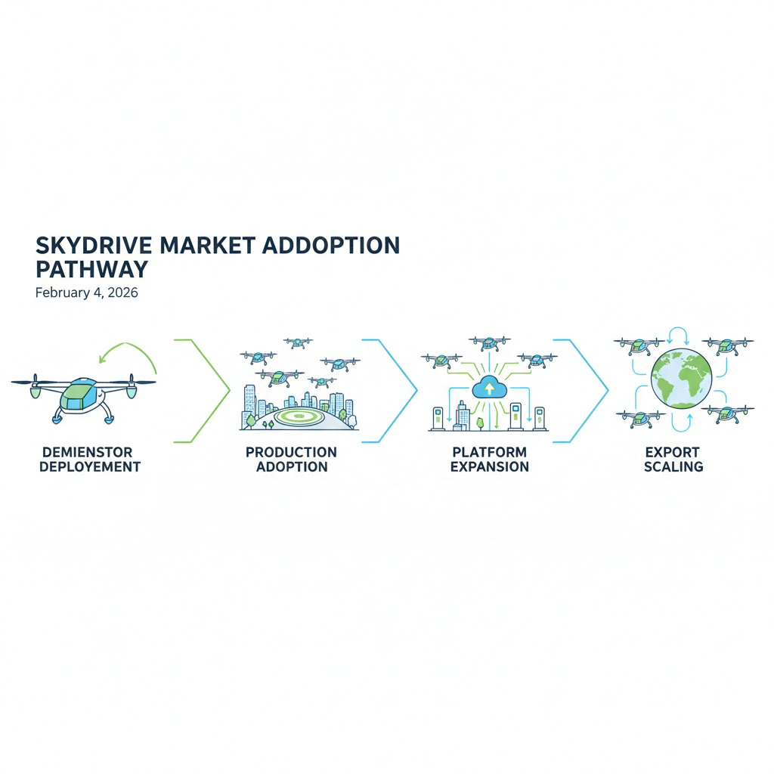
Figure 3: SkyDrive market adoption pathway
By 2040, SkyDrive targets export revenues in excess of £200 million per year, with more than 70% derived from international markets. UK value creation includes over 500 direct high skill jobs, a strengthened domestic supply chain, and anchoring of critical electric propulsion IP and manufacturing capability within the UK.

To demonstrate how SkyDrive converts early platform adoption into scalable commercial value, Figure 4 (table) summarises the staged revenue logic across launch, growth, and export phases.

Phase | Platform Type | SkyDrive Role | Revenue Mechanism
Early | Pegasus | Non primary propulsion | Unit supply + integration
Mid | Linx P9 | Primary propulsion | Higher value system supply
Scale | Other OEMs | Licensed or supplied modules | Export unit sales
Long term | Tier1 adoption | Product family | Recurring services
Figure 4: Revenue logic table

7.5. Adoption Barriers, Risks, and Mitigation using Industry Evidence

Certification, cost, and market adoption remain the primary barriers to electric propulsion deployment. SkyDrive mitigates these risks through early and continuous engagement with certification authorities, supported by Eaton’s aerospace compliance expertise, and by embedding fault tolerance and diagnostics within the architecture from the outset. ARC has confirmed that SkyDrive’s initial role as a non-primary propulsion system enables certification as an aircraft component, allowing early in-flight data capture. This provides a lower risk, cost effective pathway to de risk full propulsion certification at later TRL stages.

Market adoption risk is addressed through demonstrator and staged integration pathways. Many early electric aviation programmes rely on retrofit approaches, which provide rapid demonstration but are inherently constrained by battery only architectures, limited redundancy, and certification complexity. SkyDrive is designed as a purpose-built propulsion system, enabling improved range, fault tolerance, and scalable certification through integrated hybridisation and modular architecture.

Feature | Harbour Air Retrofit | SkyDrive Hybrid Propulsion
Power Density | ~1.0 kW/kg (battery-only) | Target 2.0–2.5 kW/kg
Range | 30–60 min | >2 hours (with fuel cell)
Redundancy | Limited (single motor) | Multi-phase & modular
Weight Impact | High (battery mass) | Optimised hybrid storage
Certification Path | Retrofit adaptation | Purpose-built compliance
Figure 5: Feature Harbour Air Retrofit SkyDrive Hybrid Propulsion
High initial development cost is mitigated through ATI co investment and the use of UK based subcontractors with proven aerospace capability, ensuring value for money and minimising overseas leakage. Manufacturing scalability risk is reduced by leveraging iNetic’s AS9100 certified facilities and established supply chain, combined with Eaton’s industrialisation and global market access experience.

Through these measures, SkyDrive presents a credible, scalable, and commercially compelling business opportunity that accelerates zero emission aviation while delivering long term economic value to the UK. ARC has confirmed willingness to support post project TRL 7 to 9 progression through provision of ground test rigs, suitable air vehicles, and potential joint commercial structures, ensuring continuity beyond ATI funding.

7.6. OEM and Tier 1 Buyer Decision Drivers and Risk Reduction Value

From an OEM and Tier1 buyer perspective, the principal challenge in adopting electric or hybrid propulsion is programme risk, certification burden, and time to market uncertainty, rather than access to core technology. Developing propulsion systems in house requires significant capital investment, long development cycles, and exposure to regulatory risk, particularly for organisations whose primary competence lies in airframe design. SkyDrive addresses this by offering a pre-integrated, aerospace optimised propulsion system designed from the outset around certification readiness, operational reliability, and system level risk reduction, enabling OEMs to shorten development timelines and focus internal resources on platform differentiation.

Tier1 suppliers place high value on integrated certification artefacts that reduce downstream compliance effort and integration risk. SkyDrive is structured to generate reusable safety analyses, environmental qualification data, and fault tolerance evidence aligned with emerging CAA and EASA expectations, with early guidance from Eaton as a Tier1 aerospace partner providing certification and industrialisation insight. This ensures the system transitions beyond demonstration toward industrial acceptance.

Modularity further reduces programme risk by enabling staged adoption rather than full propulsion replacement at entry into service. The SkyDrive IM architecture supports incremental integration, including use in non-primary propulsion roles, enabling early validation and learning without exposing aircraft programmes to single point certification dependency. Deployment with ARC Aero Systems provides early in-flight operational data through a staged pathway from Pegasus to Linx P9, supporting accelerated certification planning, insurer confidence, and customer assurance. Together, these factors position SkyDrive as a risk reduction procurement solution that supports faster market entry and scalable international adoption, strengthening the export competitiveness of UK designed and manufactured electric propulsion systems.

7.7. Market Timing and Strategic Window

The timing of SkyDrive aligns with a critical inflection point in global aerospace electrification. Regulatory pressure to decarbonise aviation is increasing and is no longer discretionary, with clear trajectories set by UK, European, and international authorities. OEMs are therefore required to demonstrate credible pathways toward lower emission propulsion within defined timeframes, creating near term demand for certifiable hybrid and electric solutions rather than speculative long-term concepts.

At the same time, OEMs are converging on hybrid architectures as a pragmatic response to current battery energy density limitations. Fully electric solutions remain constrained in range and payload for many use cases, particularly in regional aviation, driving demand for integrated hybrid systems that combine batteries with alternative energy sources such as hydrogen fuel cells. SkyDrive directly addresses this requirement through a hybrid ready architecture optimised for aerospace duty cycles.

Certification frameworks for electric propulsion are also emerging now, rather than at a future point. Guidance from CAA and EASA is actively evolving, and early programmes that engage with regulators during this formative phase are better positioned to shape compliance approaches and accelerate approval. SkyDrive’s development at this stage enables alignment with these frameworks as they mature, rather than retrofitting compliance later at higher cost and risk.

Finally, the UK faces a narrow strategic window to establish leadership in integrated electric propulsion before market dominance consolidates around US and EU suppliers. Timely investment through ATI enables UK based organisations to capture early platform positions, anchor certification and manufacturing capability domestically, and secure export opportunities before supply chains and standards become locked in internationally.

